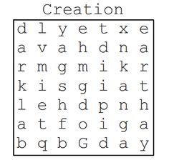
animal God
dark light
day night
earth sea

