Craft: Stained Glass Jar Light

You will need: • Paper or cardstock • Tissue paper • Clear jars (Mason jars, baby food jars, jam jars, etc.), washed and dried. • Glue • Scissors • Salt or glitter (optional)
Procedure:
1. Cut the tissue paper into small squares, approximately an inch or so.
2. Spread glue over the jar. This may be easier if a bit of water is added to the glue, and then spread on with a brush.
3. Arrange the tissue paper around the jar, pressing onto the glue
4. Add an additional layer of glue if necessary.
5. Apply salt or glitter to the outside, if desired.
6. Attach a verse caption.
7. Place a small battery-powered light into the jar to shine.

Craft: make a lamp like Jesus would have used
Make some salt dough with 2 cups flour, 1 cup of salt and 1 cup of water.
Then mould it into a lamp like this:
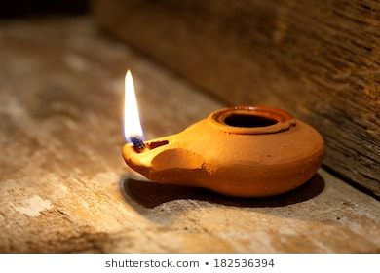
If it’s not too big you can dry it out in the oven (150C for an hour)
When it’s dry you could paint it and seal it with watered down PVA glue.

