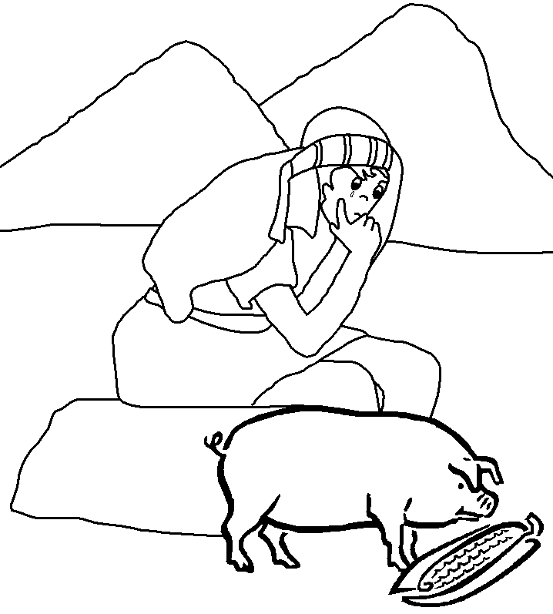
The son wasted all his money.
He got a job looking after someone’s pigs.
He got so hungry he wanted to eat the pig food.
Then he realised that even his father’s servants had enough to eat.
He decided to go home and tell his father his father he was sorry.
He knew he didn’t deserve to be his son.

