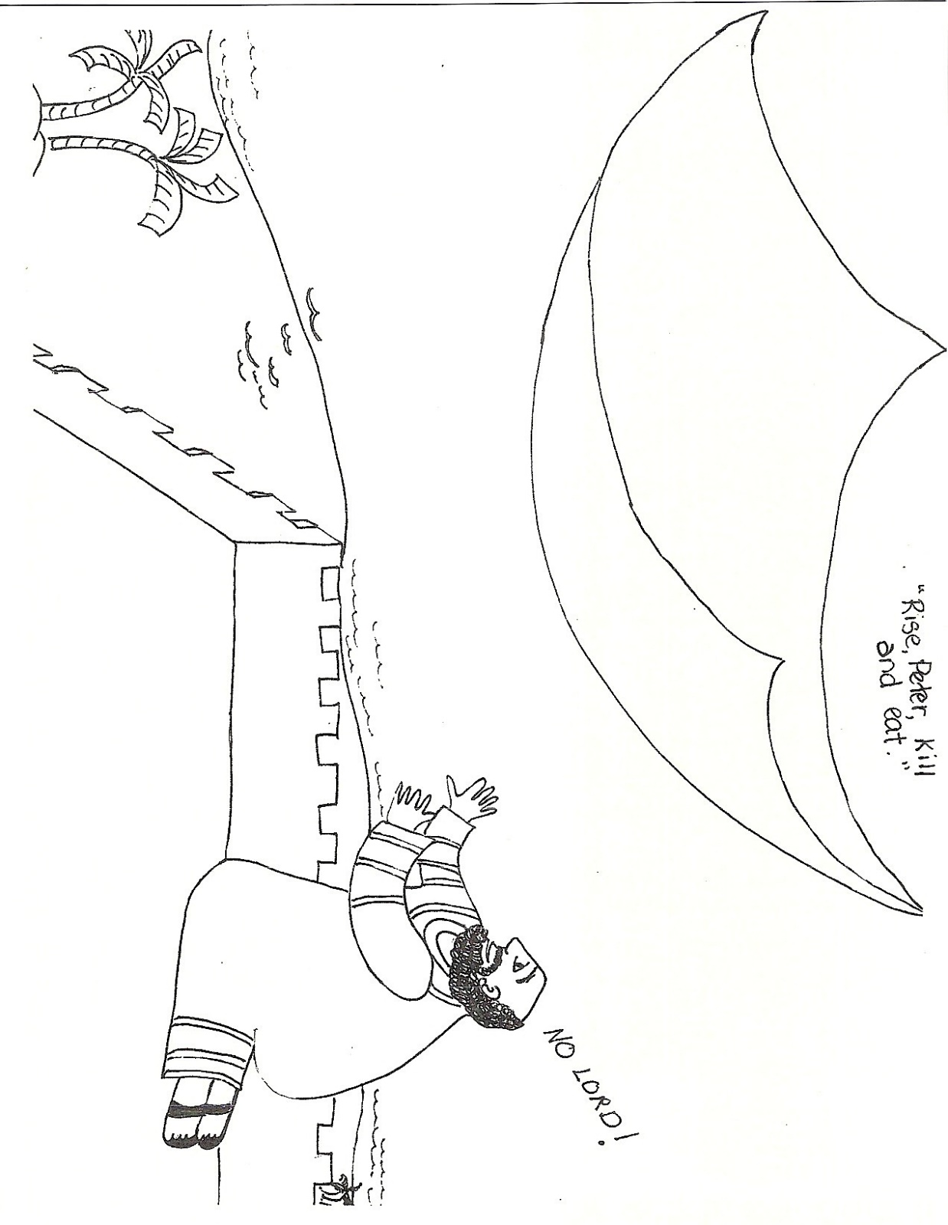
Can you draw the animals which Peter saw in the sheet?

