Mini Sheep
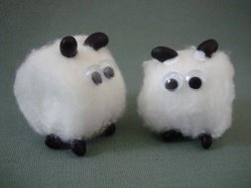
These Mini Sheep are so easy to make, yet they are so adorable.
Make one or a whole flock!
Here's what you'll need...
• Cotton balls
• Dried black beans**
• Glue
• Google eyes
Here's how you make them...
1. Glue four black beans on one side of a cotton ball.
These will be the sheep's legs.
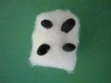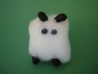
2. Turn your sheep on it's feet and glue two more beans on top to make the sheep's ears. Glue on two google eyes and you're done!
To give it an extra cute touch, tie a tiny piece of ribbon into a bow and glue it onto the side of your sheep.
**If you don’t have black beans or google eyes just cut some shapes out of black card

