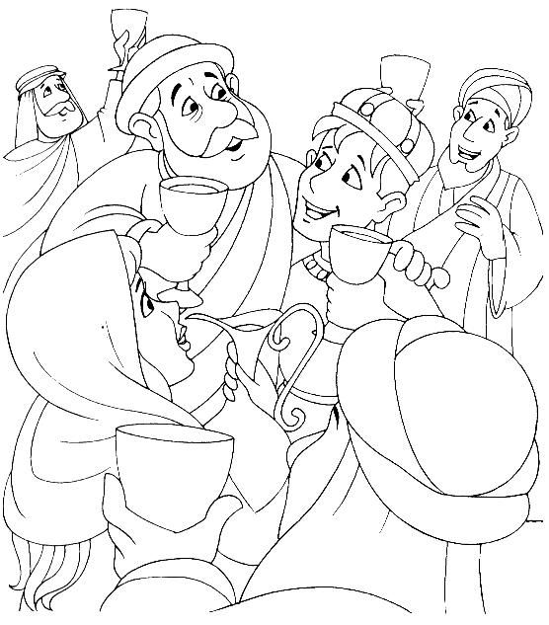
“Celebrate with me” said the father, “for this son of mine was lost and now he is found.”
Read the whole story in Luke chapter 15.

