Cut out the circle and the shape above Solomon’s head. Use a split pin/paper fastener through the point marked A and fix the circle behind the picture of Solomon. Then turn the circle to see what he dreamed about.
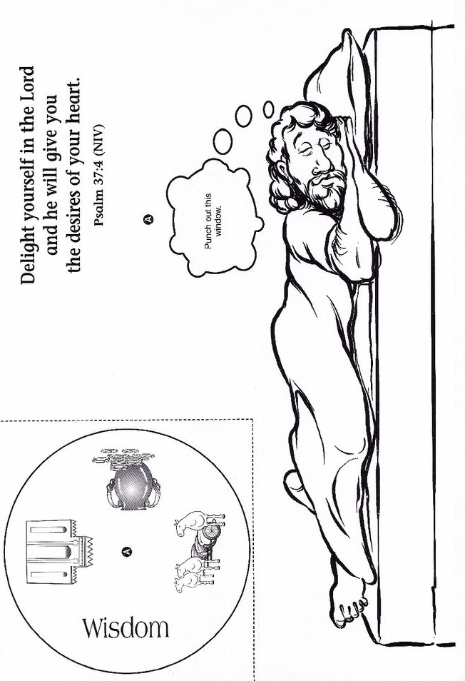
What did he choose?

